10.69: a) The distance the marble has fallen is 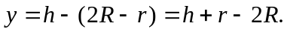 The radius of the path of the center of mass of the marble is 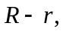 so the condition that the ball stay on the track is 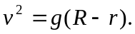 The speed is determined from the work-energy theorem, 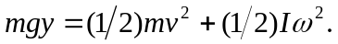 At this point, it is crucial to know that even for the curved track, 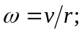 this may be seen by considering the time T to move around the circle of radius 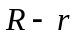 at constant speed V is obtained from 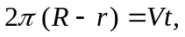 during which time the marble rotates by an angle 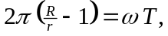 from which 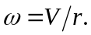 The work-energy theorem then states 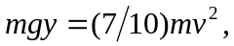 and combining, canceling the factors of m and g leads to 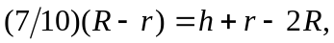 and solving for h gives 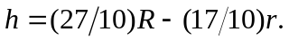 b) In the absence of friction, 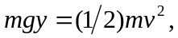 and substitution of the expressions for y and 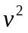 in terms of the other parameters gives 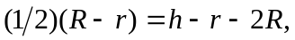 which is solved for 